**SQL Project**

**Facebook Database**

**ER Diagram:--**

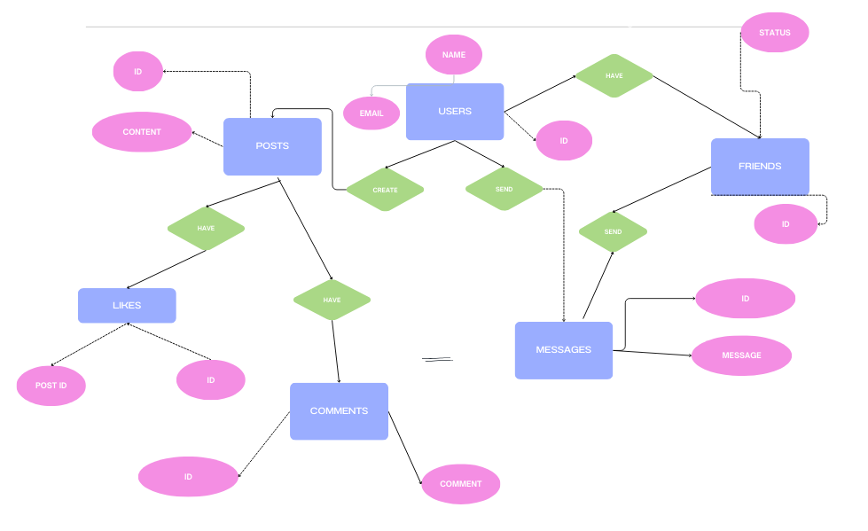

**Creating tables**

CREATE TABLE users (uid INT PRIMARY KEY, name VARCHAR(50), NOT NULL, email VARCHAR(40) UNIQUE NOT NULL, age VARCHAR(10), phone_number VARCHAR(30) UNIQUE NOT NULL, date_of_birth DATE NOT NULL, gender VARCHAR(5), city VARCHAR(50), created_at DATETIME DEFAULT current_timestamp);

CREATE TABLE posts (p_id INT PRIMARY KEY, uid INT, content VARCHAR(50) NOT NULL, image_url VARCHAR(40), created_at DATETIME DEFAULT current_timestamp, CONSTRAINT FOREIGN KEY (uid) REFERENCES users(uid));

CREATE TABLE likes (like_id VARCHAR(30) PRIMARY KEY, uid INT, p_id INT, created_at DATETIME DEFAULT current_timestamp, CONSTRAINT FOREIGN KEY (uid) REFERENCES users(uid), CONSTRAINT FOREIGN KEY (p_id) REFERENCES posts(p_id));

CREATE TABLE friends (friend_id VARCHAR(40) PRIMARY KEY, uid INT, p_id INT, status VARCHAR(30) DEFAULT ‘Pending’, created_at DATETIME DEFAULT current_timestamp, CONSTRAINT FOREIGN KEY (uid) REFERENCES users(uid), CONSTRAINT FOREIGN KEY (p_id) REFERENCES posts(p_id));

CREATE TABLE comments (comment_id VARCHAR(30) PRIMARY KEY, uid INT, p_id INT, comment VARCHAR(50) NOT NULL, created_at DATETIME DEFAULT current_timestamp, CONSTRAINT FOREIGN KEY (uid) REFERENCES users(uid), CONSTRAINT FOREIGN KEY (p_id) REFERENCES posts(p_id));

CREATE TABLE messages (message_id VARCHAR(30) PRIMARY KEY, sender_id INT, receiver_id INT, message VARCHAR(50) NOT NULL, created_at DATETIME DEFAULT current_timestamp, CONSTRAINT FOREIGN KEY (sender_id) REFERENCES users(uid), CONSTRAINT FOREIGN KEY (receiver_id) REFERENCES users(uid));

**Inserting data in** **tables :--**

INSERT INTO users (uid, name, email, phone_number, date_of_birth, gender, city)

VALUES (1, ‘Addison Garcia’, [‘addigar@gmail.com’](mailto:‘addigar@gmail.com’), 3902843029, 09-08-2000, ‘F’, ‘New York’),

(2, ‘Ashley Davis’, [‘ashdavis@email.com’](mailto:‘ashdavis@email.com’), 578709430, 04-02-1998, ‘F’, ‘Chicago’),

(3, ‘Ethan Williams’, [‘ethan.w@gmail.com’](mailto:‘ethan.w@gmail.com’), 90450902, 17-04-1994, ‘M’, ‘Washington’),

(4, ‘Mark Smith’, [‘mksmith@mail.com’](mailto:‘mksmith@mail.com’), 75024989, 13-06-2013, ‘M’, ‘New York’),

(5, ‘Johnny Miller’, [‘millerj.y@gmail.com’](mailto:‘millerj.y@gmail.com’), 694837522, 12-09-1994, ‘M’, ‘Washington),

(6, 'Vincent Frank’, [‘vinfran23@email.com’](mailto:‘vinfran23@email.com’), 592019833, 04-12-1992, ‘M’, ‘Chicago’),

(7, ‘Candace Fischer’, [‘candypop@gmail.com’](mailto:‘candypop@gmail.com’), 43208032, 09-03-1993, ‘F’, ‘Springfield’),

(8, ‘Florence Garner’, [‘flowergarden@mail.com’](mailto:‘flowergarden@mail.com’), 897098036, 18-02-1994, ‘F’, ‘Austin’),

(9, ‘Mina Swanson’, [‘mina.swan7@email.com’](mailto:‘mina.swan7@email.com’), 239085904, 13-10-1995, ‘F’, ‘Austin’),

(10, ‘Rose Quinn’, [‘rosiequeen@gmail.com’](mailto:‘rosiequeen@gmail.com’), 7540285092, 30-12-1995', ‘F’, ‘Springfield’);

INSERT INTO posts (p_id, uid, content)

VALUES (101, 1, ‘My best moment is yet to come’),

(102, 2, ‘Hello WORLD’),

(103, 3, ‘I am on the next level’),

(104, 3, ‘you should have fun’),

(105, 5, ‘Hey! You never walk alone’),

(106, 6, ‘please give me a remedy’),

(107, 7, ‘follow the lead of Maestro’),

(108, 2, ‘I am the one I should love in this world’),

(109, 9, ‘trust the process’),

(110, 1, ‘follow for more such content’);

INSERT INTO likes (like_id, uid, p_id)

VALUES

(#1, 1, 104), (#2, 2, 101), (#3, 3, 102), (#4, 4, 108), (#5, 5, 105), (#6, 6, 103), (#7, 7, 109), (#8, 8, 101), (#9, 9, 102), (#10, 10, 107), (#11, 4, 109), (#12, 1, 110), (#13, 6, 102), (#14, 8, 108), (#15, 2, 106);

INSERT INTO friends (friend_id, uid, status)

VALUES ($1, 101, ‘Accepted’),

($2, 102, ‘Pending’),

($3, 103, ‘Pending’),

($4, 104, ‘Denied’),

($5, 105, ‘Accepted’),

($6, 106, ‘Pending’),

($7, 107, ‘Denied’),

($8, 108, ‘Denied’),

($9, 109, ‘Accepted’),

($10, 110, ‘Accepted’);

INSERT INTO comments (comment_id, uid, p_id, comment)

VALUES (A1, 1,101, ‘hello’),

(A2, 2, 102, ‘believe’),

(A3, 3, 103, ‘happy’),

(A4, 4, 104, ‘sweet’),

(A5, 5, 109, ‘looking good’),

(A6, 6, 107, ‘fashion street’),

(A7, 7, 106, ‘new jeans’),

(A8, 8, 105, ‘black magic’),

(A9, 9, 104, ‘true form’),

(A10, 3, 108, ‘secret garden’),

(A11, 10, 110, ‘not much’),

(A12, 8, 102, ‘friends of mine’),

(A13, 6, 103, ‘look at me’),

(A14, 9, 105, ‘mysterycase’),

(A15, 1, 108, ‘you are welcome’);

INSERT INTO messages (message_id, sender_id, receiver_id, message)

VALUES (1&, 102, 103, ‘hey wassup’),

(2&, 108, 106, ‘what do you think’),

(3&, 109, 101, ‘please do my work too’) ,

(4&, 105, 107, ‘lets start a business’),

(5&, 109, 104, ‘i would like to buy this product’),

(6&, 108, 103, ‘are you free today?’),

(7&, 106, 109, ‘tell everyone to meet today’),

(8&, 110, 101, ‘i am very busy’),

(9&, 101, 109, ‘no i cannot do your work’),

(10&, 102, 104, ‘you do not remember it?’);

**Questions :--**

1. Get all users’ details from the Users table.

**Answer**: SELECT * FROM users;

2. Get all posts created by a user with the user_id = 1.

**Answer**: SELECT uid, p_id FROM posts WHERE uid = 1;

3. Find all users from the city of ‘New York’

**Answer**: SELECT * FROM users WHERE city = ‘New York’;

4. Get all friends of user with user_id = 101 whose friendship status is “Accepted”

**Answer**: SELECT uid, friend_id FROM friends WHERE status = “Accepted”;

5. Find all posts created between 2024-01-01 and 2024-09-01.

**Answer**: SELECT * FROM posts WHERE created_at BETWEEN ‘2024-01-01' AND ‘2024-09-01

6. Get details of users from the city of Chicago, Los Angeles, or San Francisco.

**Answer**: SELECT name, city FROM users WHERE name IN (‘Chicago’, ‘Los Angeles’, ‘San Francisco’);

7. Find all users whose email address ends with [‘@gmail.com’](mailto:‘@gmail.com’).

**Answer**: SELECT name, email FROM users WHERE email like ‘%@gmail.com’;

8. Get the number of posts created by each user.

**Answer**: SELECT uid, COUNT(posts.uid) FROM posts

LEFT JOIN users ON users.uid = posts.uid

GROUP BY posts.uid;

9. Get the total number of likes on each post.

**Answer**: SELECT p_id, COUNT(likes.like_id) FROM likes

LEFT JOIN posts ON likes.p_id = posts.p_id

GROUP BY p_id;

10. Get all comments on a specific post along with the user name of the commenter.

**Answer**: SELECT p_id, name, COUNT(comment_id) FROM comments

LEFT JOIN users ON comments.uid = users.uid

GROUP BY comments.p_id;

11. Get all posts liked by a specific user along with the post content and the user who

posted it.

**Answer**: SELECT p_id, name, COUNT(like_id) FROM likes

LEFT JOIN users ON likes.uid = users.uid

GROUP BY likes.p_id;

12. Get the most liked post.

**Answer**: SELECT like_id, p_id FROM likes, MAX(COUNT(like_id));

13. Find the users who haven&#39;t posted anything yet.

**Answer**: SELECT uid, p_id FROM posts

RIGHT JOIN users ON posts.uid = users.uid;

14. Get the first 10 characters of each post’s content.

**Answer**: SELECT * FROM posts, LEFT(content, 10);

15. Convert all user names to uppercase.

**Answer**: SELECT name, UPPER(name) FROM users;

16. Get the top 5 users who have received the most likes on their posts.

**Answer**: SELECT uid, like_id, COUNT(like_id) FROM likes

ORDER BY COUNT(like_id) DESC

LIMIT 5;

17. Get the users who have more than 100 friends.

**Answer**: SELECT uid, friend_id FROM friends

RIGHT JOIN users ON users.uid = friends.uid

GROUP BY uid;

18. Show the friendship status as ‘Friends’ if the status is ‘Accepted’, ‘Pending’ if its

pending, and ‘Not Friends’ for any other status.

**Answer**: SELECT friend_id, status

CASE

WHEN status = ‘Accepted’ THEN ‘Friends’

WHEN status = ‘Pending’ THEN ‘Pending’

ELSE ‘Not Friends’

END AS status_category

FROM friends;

19. Get all private messages between two users (user_id = 101 and user_id = 102).

**Answer**: SELECT * FROM messages;

20. Categorize the post length as ‘Short’, ‘Medium’, or ‘Long’ based on character count

(e.g., < 50 characters = ‘Short’, 50-100 = ‘Medium’, >100 = ‘Long’).

**Answer**: SELECT p_id, content

CASE

WHEN content < 50 THEN ‘Short’

WHEN content BETWEEN 50 AND 100 THEN ‘Medium’

ELSE ‘Long’

END AS post_length

FROM posts;

21. Display the user’s age category as ‘Minor’ if their age is less than 18, ‘Adult’ if

their age is between 18 and 60, and ‘Senior’ if their age is greater than 60.

**Answer**: SELECT name, age,

CASE

WHEN age < 18 THEN ‘Minor’

WHEN age BETWEEN 18 AND 60 THEN ‘Adult’

ELSE ‘Senior’

END AS age_category

FROM users;

Extra questions:-

1. Get user details of users who are male and live in Chicago
2. Total number of comments on posts
3. Number of posts created by users who are Senior
4. Most commented post

**Answer**s:-

1. SELECT * FROM users WHERE gender = ‘M’ AND city = ‘Chicago’;
2. SELECT uid, COUNT(comment_id); as total_comments FROM comments;
3. SELECT p_id, age FROM users

RIGHT JOIN posts ON posts.uid = users.uid

WHERE age > 60

GROUP BY uid;

1. SELECT MAX(COUNT(comment_id)) FROM comments;